Production Function Identification for the Computer and Electronic Products Manufacturing Industry

Alexander Peralta

Indiana University – Kelley School of Business
May 4, 2025
1. Introduction
Commonly, production functions are estimated by economists using data for which companies have been de-identified by the data provider. For example, Olley and Pakes (1996) used de-identified plant-level data from the U.S. Census Annual Survey of Manufacturers, Levinsohn and Petrin (2003) used de-identified plant-level data from the Chilean Annual National Industrial Survey, and Ackerberg, Caves, and Frazer (2015) used de-identified plant-level data from the Colombia Annual Manufacturing Survey. By using de-identified data, economists are limited to analyzing industries at the level of aggregation determined by the data provider.
To overcome this limitation, I propose an alternative approach using quarterly firm-level financial statement data from Compustat Capital-IQ, allowing production function identification at the sub-industry level. Specifically, I implement and compare multiple production function estimation techniques (e.g., Fixed Effects Models, as well as the Olley-Pakes and Ackerberg-Caves-Frazer methods) offering new insights into the effectiveness of these approaches when applied to financial statement data. In doing so, I provide novel estimates of production functions for the Computer and Electronic Products Manufacturing Industry.
2. Data
Using the SEC Ticker Mapping API, I retrieved a list of all public companies who have filed financial statements with the SEC, as well as the CIK Numbers and SIC Codes associated with these companies. I then filtered this list to only include companies with SIC Codes that correspond to the NAICS Code for the Computer and Electronic Product Manufacturing Industry. Finally, I used Compustat Capital-IQ to collect annual and quarterly financial statement data for all companies in the filtered list for the years 2010 through 2025.
This process described above resulted in two unbalanced panel datasets: one dataset for quarterly financial data, which includes 25,645 observations, and another dataset for annual financial data, which includes 8,169 observations. The dataset for annual financial data includes total revenue (output), employment (labor), and variables that can be used to approximate capital.
3. Identifying Simultaneity Bias and Measurement Error
I start with a Cobb-Douglass production function $Y=zF\left(K, L\right)$ where $Y$, $z$, and $F\left(K, L\right)$ are output, total factor productivity, and an unspecified function of capital and labor, respectively. The production function can be rewritten to explicitly state capital and labor:
 | $$Y_{it}=zK_{it}^{α}L_{it}^{β}$$ | (3.1)
where the subscript $i$ relates capital and labor to a specific firm and subscript $t$ relates the time period to a specific firm. The production function in (3.1) assumes that capital evolves according to the law of motion for capital accumulation:
 | $$K_{it}=\left(1-δ_{it}\right)K_{it-1}+I_{it-n}$$ | (3.2)
where capital expenditure (investment) is calculated as:
 | $$I_{it-n}=K_{it}-K_{it-n}+Current Depreciation_{it}$$ | (3.3)
That is, investment for firm $i$ at time $t-n$ is equal to the difference between the capital stock of firm $i$ in the current period and the capital stock of firm $i,$ $n$ periods ago, plus depreciation in the current period for firm $i$. The subscript $t-n$ is used to represent that it takes investment $n$ periods to materialize into capital; that is, I use an n-period lag on investment.
Similar to Levinsohn-Petrin (2003), I approximate capital ($K_{it}$ and $K_{it-n}$) by taking the sum of inventory, as well as depreciated property, plant, and equipment for a given firm during the appropriate periods.
Because the depreciation rate is $δ_{it}=\frac{Depreciation_{it}-Depreciation_{it-1}}{K_{it-1}}$, (3.2) can be rewritten as:
 | $$K_{it}=K_{it-1}-Depreciation_{it}+I_{it-n}$$ | (3.4)
I calculate 2 measures of capital using (3.4) in Python. The first measure of capital (capital measure 1) does not use a lag on investment, and the second measure of capital (capital measure 2) uses a 3-quarter lag on investment. I denote the regression models using the first and second measures of capital as Model 1 and Model 2, respectively.
Quarterly employment is estimated using a quantile regression forest (QRF), as explained in Appendix A1.
To estimate the production function in (3.2), I take the logarithm of both sides of the equation:
 | $$\log\left(Y_{it}\right)=\log\left(z\right)+α\log\left(K_{it}\right)+β log(L_{it})$$ | (3.5)

Variable | Observations | Median  (in millions) | St. Dev.  (in millions) | Min  (in millions) | Max  (in millions)
Log Value Added | 6,648 | 4.16 | 2.36 | -6.91 | 11.02
Log Labor | 6,648 | -0.79 | 1.35 | -5.95 | 0.87
Log Capital Measure 1 | 6,648 | 6.62 | 2.36 | -1.16 | 12.63
Log Capital Measure 2 | 6,648 | 6.64 | 2.36 | -1.55 | 12.57
Table 3.1: Summary Statistics for Equation (3.5) Parameters
Table 3.1 presents summary statistics for the variables in Equation (3.5). The data suggest that larger firms are overrepresented in the sample. The median of log value added is 4.16, with a standard deviation of 2.36; this corresponds to a median annual revenue of approximately $64.07 million ($e^{4.16}≈4.16$). The large median implies that the largest firms dominate the sample distribution. In terms of production function identification, the overrepresentation of the largest firms may overexaggerate the identification of scale effects in the production function, as estimates would be driven primarily by large firms. For example, if larger firms exhibit increasing returns to scale due to greater capital intensity or organizational efficiency, their dominance in the sample may lead to an overestimation of output elasticities or mask nonlinearities in the production function. As a result, the estimated coefficients may primarily reflect the technology and input-output relationships of large firms, potentially misrepresenting the true production structure of the industry.
Running a regression using (3.5) would require data on total factor productivity. Because I do not have data on total factor productivity, the regression specification for (3.5) can be modified by absorbing total factor productivity in the error term:
 | $$y_{it}=β_{0}+β_{1}k_{it}+β_{2}l_{it}+ϵ_{it}$$ | (3.6)
Here, all variables are in logarithmic form, and $ϵ_{it}$ represents the error term, which captures unobserved productivity shocks and measurement error. In equation (3.6), I impose no additional assumptions about the error term. Subsequently, total factor productivity can be computed using the Solow Residual:
 | $${TFP}_{it}=ϵ_{it}=exp⁡(y_{it}-β_{0}+β_{1}k_{it}+β_{2}n_{it})$$ | (3.7)
To identify simultaneity bias and measurement error for the simple production function (3.6), I ran an ordinary least squares regression in Python using equation (3.6). The summary statistics for this regression are presented in Table 3.2.
 | Model 1 | Model 2
Const | 0.44*** | 0.43***
Capital | 0.65***  (0.01) | 0.65***  (0.00)
Labor | 0.57***  (0.02) | 0.57***  (0.02)
Number of Observations | 6,648 | 6,648
R-Squared | 0.92 | 0.92
F-Stat | 40,573.58 | 39,681.26
SSR | 2,807.60 | 2,865.85
Table 3.3: Regression Summary for Equation (3.6)
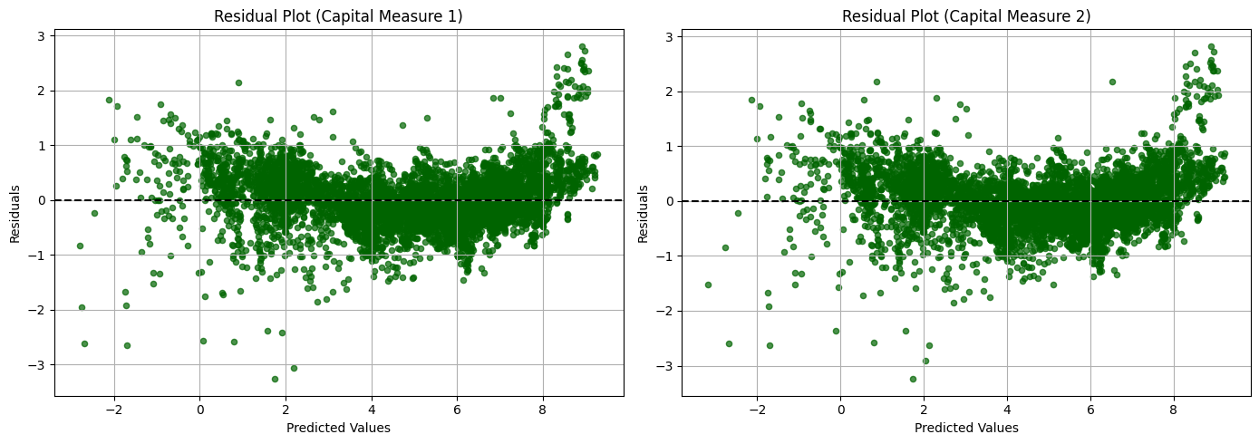
Figure 3.1: Scatter Plot of Predicted Values vs Residual Values
As outlined in Levinsohn-Petrin (2003), the coefficient on labor in both models overestimates the actual effect of labor on output, and the coefficients on capital underestimate the actual effect of capital on output. This suggests that capital and labor are positively correlated, and that labor is more strongly correlated with unobserved productivity shocks than is capital; that is, the estimates may suffer from simultaneity bias.
The upward bias on the coefficient for capital also indicates the presence of measurement error for the measure of capital. That is, based on Collard-Wexler and De Loecker’s (2022) findings on capital mismeasurement in firm-level data, the coefficient on labor is picking up “the true capital variation through the positive correlation of labor and (true) capital and thus overestimate the impact of labor on output variation.”
In addition to simultaneity bias and measurement error, the simple models also suffer from unobserved heterogeneity across units. Specifically, between-unit variation accounts for 81.08% of total variance. This high proportion suggests that most of the variation in the output is explained by persistent differences across firms rather than within-unit (i.e., over-time) variation, highlighting the need for models that appropriately account for fixed effects or latent heterogeneity.
4. Examining Methods to Correct the Production Function for Endogeneity
4.1. Fixed Effects Models
In his 1969 paper, Irving Hoch noted that using least squares estimates of Cobb-Douglas production function parameters will lead to simultaneity bias, as the inputs are correlated with the error term. That is, given the output formula and the input demand formula as follows:
 | $x_{0i}=k_{0}+\sum_{q}{a_{q}x_{qi}+u_{i}}$ | (4.1.1)
 | $$x_{qi}=c_{q}+x_{0i}+v_{qi}$$ | (4.1.2)
Substituting the output equation into the input demand equation:
 | $x_{qi}=c_{q}+k_{0}+\sum_{q}{a_{q}x_{qi}+u_{i}}+v_{qi}$ | (4.1.3)
shows that $x_{qi}$ is a function of both $x_{qi}$ and $u_{i}$, which implies that input demand is selected based on the error term and that the specification in (4.1.1) is endogenous.
To avoid simultaneity bias, Hoch suggested the use of “combined time-series and cross-section data” to include firm and time fixed effects in production function estimation. Firm fixed effects reflect differences in technical efficiency, while time fixed effects reflect “change in technical efficiency over time and differences in whether between” and potentially “changes in both relative prices and the general price level”:
 | $mpq=\sum_{i}{\sum_{t}{\left(x_{pit}-{\bar{x}}_{pi}-{\bar{x}}_{qt}+{\bar{\bar{x}}}_{p}\right)\left(x_{qit}-{\bar{x}}_{qi}-{\bar{x}}_{qt}+{\bar{\bar{x}}}_{q}\right)}}$ | (4.1.4)
where ${\bar{x}}_{p_{i}}$ removes time-invariant firm differences to show how the firm deviates from its own average, ${\bar{x}}_{p_{i}}$ removes time-invariant year differences to show how the firm deviates from its own average and the year’s average, and ${\bar{\bar{x}}}_{p}$ adjusts for the removal of both firm and time averages. This transformation isolates the variation in $x_{p_{it}}$ that is not due to either the firm's average level or the year's average level, which provides a consistent and unbiased estimate of the firm’s production function under certain conditions.
To estimate the production function while addressing simultaneity bias arising from unobserved firm-specific and time-specific heterogeneity, I implement a fixed effects panel regression model following the approach proposed by Hoch. The model specification is as follows:
 | $$\log\left(Y_{it}\right)=α_{i}+δ_{t}+β_{1}\log\left(K_{it}\right)+β_{2}\log\left(L_{it}\right)+ϵ_{it}$$ | (4.1.5)
where $Y_{it}$ is total revenue for firm $i$ at time $t$, $K_{it}$ is capital, $L_{it}$ is labor, $α_{i}$ denotes firm fixed effects, and $δ_{t}$ captures time fixed effects. Table 4.1.1 presents the regression results for (4.1.5).
 | Model 1 | Model 2
Constant | 3.13 | 3.44
Capital | 0.28  (0.039) | 0.23  (0.038)
Labor | 0.81  (0.069) | 0.85  (0.070)
R-Squared | 0.4286 | 0.4180
F-Stat | 2,332.2 | 2,233.2
Number of Observations | 6,648 | 6,648
Table 4.1.1: Fixed Effects Regression Results
Relative to the ordinary least squares regression results from Table 3.2, time and firm fixed effects appears to have increased measurement error for both models. Further, the results for the fixed effects regression still indicate the presence of measurement error, as the coefficient estimates for capital and labor tend to overstate the contribution of labor to output, and the coefficient for capital is biased downwards. There are several reasons why this may be the case.
First, both Olley-Pakes (1996) and Griliches and Mairess (1995) show that “firms with a large capital stock are more likely to remain in business and tolerate lower productivity levels”, which may “introduce a negative bias in $β_{K}$”. A negative coefficient for the capital coefficient could be explained by the fact that “capital is a fixed factor of production, and, therefore, the variation left in the time series is essentially noise.” That is, because firms are generally able to hire and fire workers faster than they are able to operationalize and sell-off capital, large firms are likely to hold on to capital during business cycle contractions, during which output may be below trend.
Second, fixed effects models assume that firm-specific productivity is constant over time. However, this assumption is often violated, as firms experiencing positive productivity shocks are more likely to increase inputs and survive, introducing a selection problem that fixed effects cannot fully address. If this selection is not orthogonal to input decisions, fixed effect estimators may yield biased coefficients. Based on the regression results for the fixed effects model, the upward bias of the labor coefficient reflect the fact that firms adjust labor more rapidly in response to shocks than they do capital, which is typically more fixed in the short run. As a result, observed changes in labor may be confounded with transitory productivity shocks, inflating its estimated effect.
Finally, while the QRF model provides a flexible and accurate approach for estimating employment from annual firm characteristics, its predictions exhibit limited within-firm variation due to the quantile-based structure. As a result, labor input values are clustered and discretized, reducing the effective signal available for identifying labor elasticities in fixed effects regressions. This contributes to the attenuation and instability of the estimated labor coefficient and may exacerbate the effects of measurement error.
4.2. The Olley-Pakes Model
In estimating the parameters of the production function for the telecommunications industry, Olley-Pakes (1996) noted that total factor productivity is not observable by the economist, and that “exit and input demand decisions” are made by companies based on total factor productivity, which generated the “simultaneity problem” and “the issue of how to handle attrition from, and additions to, the data.” The simultaneity problem would cause total factor productivity to be serially correlated with input choices, causing an upward bias in productivity differences as estimated via ordinary least squares. The problem of firm entry and exit may cause the sample to over-represent surviving firms with high-capital and low-productivity, as firms with higher capital are more likely to survive even when they have low productivity. This creates a negative correlation between capital and unobserved productivity, which leads to a downward bias in the estimated capital coefficient in OLS or models that don’t control for this selection.
To address these issues, Olley and Pakes propose a two-stage estimation method that uses investment as a proxy for productivity and models firm survival as part of the decision process.
To begin, Olley-Pakes express unobservable total factor productivity as a function of observable factors to control for productivity in estimation:
 | $$ω_{t}=h_{t}\left(i_{t}, a_{t}, k_{t}\right)$$ | (4.2.1)
This can be substituted into the production function, resulting in the following semiparametric regression model:
 | $$y_{it}=β_{l}l_{it}+ϕ\left(i_{it}, a_{it}, k_{it}\right)+η_{it}$$ | (4.2.2)
Because the semiparametric regression model does not separately identify the effects of capital and age on output (since they also influence investment), Olley and Pakes recover the coefficients on capital and age in a second stage by leveraging information from the survival decision. They estimate the probability that a firm remains in the market (i.e., the selection equation) and use it to control for selection bias caused by endogenous exit.
Specifically, the probability of survival is modeled as a function of observable state variables, which allows the researcher to condition on the selection probability (i.e., the propensity score) to recover a second index of the unobserved productivity term. For given values of $β_{α}$and $β_{k}$, the second index can be conditioned upon using the nonlinear term generated from the first-stage estimation:
 | $$ϕ\left(i_{it}, a_{it}, k_{it}\right)=β_{0}+β_{a}a_{it}+β_{k}k_{it}+h_{t}\left(i_{it},a_{it},k_{it}\right)$$ | (4.2.3)
To recover the coefficients on capital and age, which could not be separately identified in the first stage, Olley-Pakes introduce a second-stage equation that controls for selection bias due to endogenous firm exit. This equation isolates the contributions of capital and age to output in period $t+1$, after controlling for the effect of labor on output. Specifically, the authors regress $y_{t+1} -β_{l} l_{t+1}$ on $k_{t+1}$and $a_{t+1}$, along with a control function $g(⋅)$that accounts for the correlation between unobserved productivity and firm survival. The control function depends on the estimated survival probability (i.e., the propensity score) and the nonlinear productivity term from the first stage, adjusted for capital and age.
Substituting the survival probability $P_{t}$ and $ϕ_{t}$ into $g(∙)$:
 | $$y_{t+1}-β_{l}l_{t+1}=β_{a}a_{t+1}+β_{k}k_{t+1}+g(P_{t}, ϕ_{t}-β_{a}a_{t}-β_{k}k_{t}+ξ_{t+1}+η_{t+1}$$ | (4.2.4)
where $ξ_{t+1}$ is the innovation to productivity and $η_{t+1}$ is a measurement error or output shock. This approach ensures that the capital coefficient is consistently estimated even when productivity is unobserved and selection into the sample depends on it.
To estimate the first stage of the Olley-Pakes model, I specified a flexible approximation of the unobserved productivity term $ϕ(i_{it}, k_{it})$ using a third-degree polynomial in investment and capital. The labor input was included linearly, as it is assumed to be an adjustable variable correlated contemporaneously with productivity. I then estimated a linear regression of value added (i.e., total revenue minus cost of goods sold) on this flexible function of capital and investment, along with labor. The fitted values from this regression served as the first-stage estimate of the composite productivity term $ϕ(i_{it}, k_{it})$.
 | Model 2
Constant | 2.7983
Labor | 0.9156  (0.020)
R-Squared | 0.934
F-Stat | 9,401
Number of Observations | 6,648
Table 4.2.1: Olley-Pakes First-Stage Regression Results
Following the first-stage estimation, I extracted the predicted values from the regression to get an estimate the firm-specific productivity term, ${\hat{ϕ}}_{it}$. To account for selection bias from endogenous firm exit, I estimated a Probit model of firm survival on the same set of regressors used in the first stage. This allowed me to model the probability that a firm remains in the sample as a function of its observed state variables and productivity. The predicted survival probabilities from this model were saved and later used in the second-stage regression to correct for potential selection bias in the estimation of capital and age coefficients.
To implement the second stage of the Olley-Pakes model, I first dropped any firm-period observations with missing values for next-period output, capital, estimated productivity, or survival probability. I then constructed a second-degree polynomial in the first-stage productivity estimate ${\hat{ϕ}}_{it}$and the predicted survival probability to approximate the selection correction term. This flexible control function captures the correlation between unobserved productivity and the likelihood of firm survival. I included next-period capital as a separate regressor and estimated a linear regression of next-period output on this full set of variables. The coefficient on capital recovered from this regression provides a consistent estimate of the capital elasticity, accounting for both simultaneity and selection biases.
 | Model 2
Capital | 0.37
Number of Observations | 6,648
Table 4.2.2: Olley-Pakes Second-Stage Regression Results
Based on the second stage regression results, the Olley-Pakes model when applied to the data substantially reduced measurement error in capital and labor estimates relative to the ordinary least squares regression. The proxy for unobserved productivity enters positively and significantly, confirming its relevance in explaining output. The inclusion of higher-order terms interactions with survival probability suggests diminishing returns to productivity and some nonlinearity in the selection mechanism. The survival probability itself is significantly negative, while its squared term is positive, indicating that firms more likely to exit tend to be less productive, but the effect is nonlinear. The coefficient on capital is estimated at 0.37. However, the downward bias of capital suggests that the Olley-Pakes model still suffers from measurement error. There are several reasons why this may be the case.
First, to test whether investment demand can be expressed as a function of capital, age, and productivity, I implemented a robustness check proposed in their original paper. This assumption is central to identifying the labor coefficient $β_{l}$ in the first-stage regression. If this assumption is violated, the second-stage disturbance term may contain residual correlation with labor, particularly with $l_{t+1}$, since labor and unobserved productivity are likely to be correlated. To test this, I extended the second-stage regression by including $l_{t+1}$ (i.e., Total Employment in period $t+1$) as an additional regressor. Using a parametric specification, I approximated the control function $g(P_{t}, ϕ_{t} -β_{a} a_{t} -β_{k} k_{t})$ with a second-degree polynomial in the survival probability and the first-stage productivity index. The coefficient on labor was estimated at -0.8882. This result suggests that $l_{t+1}$ is significantly correlated with the second-stage error term, implying that the original estimate of $β_{l}$ may be biased. Thus, the investment demand function may not be fully captured by capital, age, and productivity alone, and the strict monotonicity condition of the investment demand equation may not hold in this context.
Second, investment may not serve as a strong or valid proxy for unobserved productivity in my sample. The identification strategy in Olley-Pakes relies critically on the assumption that investment is a strictly increasing function of productivity, conditional on capital and age. However, if investment is lumpy, subject to reporting error, or poorly measured, this relationship may be weak or non-monotonic. Additionally, if a large number of firms exhibit zero or near-zero investment in a given period, the required invertibility condition may not hold, thereby undermining the reliability of the control function. In such cases, the simultaneity correction introduced by the OP framework may introduce more noise than it resolves, resulting in greater bias than a naïve OLS estimate.
Finally, firm age is not available in the financial dataset. Age is used in the OP model both as a determinant of investment and survival, and as a control in the productivity inversion step. Excluding it may bias the control function $ϕ(i_{t}, k_{t}, a_{t})$ and the survival equation, leading to misestimation of the unobserved productivity term and undermining the second-stage corrections for selection bias. Without this variable, the model may confound the effects of capital and productivity with omitted age-related heterogeneity, weakening identification and reducing the effectiveness of the simultaneity and selection corrections.
With the labor coefficient $β_{l}$ obtained from the first-stage regression and the capital coefficient $β_{k}$recovered from the second stage, I computed firm-level total factor productivity as the residual component of output unexplained by observed inputs. Specifically, productivity was calculated as the exponent of the difference between a firm’s observed revenue and the predicted contribution of labor and capital:
 | $$\hat{TFP_{it}} =exp⁡( y_{it} -β_{l}l_{it} -β_{k}k_{it})$$ | (4.2.5)
There are a few things to note in 4.2.1. First, aggregate total factor productivity was low immediately and several years after the 2008-2009 great recession. This is likely due to the fact that companies in the Computer Manufacturing and Electronic Products industry were still recovering from the .com crisis. Many firms had overinvested in infrastructure and technologies during the tech boom, leading to a period of adjustment and underutilized capacity. Additionally, in the wake of the financial crisis, credit constraints, reduced investment, and slow diffusion of productivity-enhancing technologies likely contributed to the prolonged stagnation in TFP. Second, aggregate total factor productivity began to grow at a much higher rate after 2017. This period coincides with increased domestic investment in semiconductor and computing infrastructure, as well as rising demand for high-performance computing, cloud services, and AI-related technologies. Additionally, policy developments (e.g., early discussions of reshoring critical supply chains and the anticipation of legislation like the CHIPS Act) likely contributed to renewed capital formation and operational efficiency. The acceleration in TFP growth also aligns with a broader pivot away from low-margin commodity hardware toward more specialized and scalable technologies, signaling a move up the global value chain and a partial reversal of the offshoring trends that characterized the industry in the early 2010s.
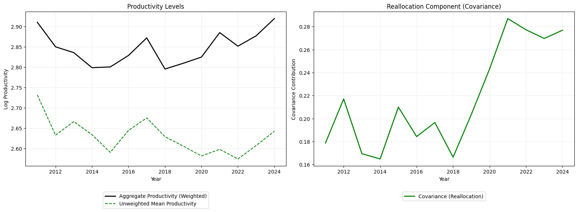
Figure 4.2.1: Industry-Level Aggregate TFP Over Time (OP Model)
Decomposing the reallocation term at the firm level reveals which firms drive the aggregate patterns. Apple (AAPL) is the single largest contributor to the reallocation component across the full sample, with a cumulative contribution more than double that of any other firm. Apple's consistently high TFP. Apple’s position as the largest contributor to the reallocation component reflects its ability to generate substantial revenue relative to its capital and labor inputs through a design-focused, asset-light business model. Nvidia’s (NVDA) reallocation contribution was modest through 2020 (approximately 0.004 annually) before surging to 0.012-0.014 in 2023-2024, making it the third-largest cumulative contributor. This jump coincides with the rapid growth in demand for GPU computing driven by artificial intelligence applications, as NVIDIA's TFP more than doubled from approximately 2.2 in 2020 to 5.3 in 2024 – the largest absolute productivity gain in the sample. Intel (INTC) illustrates the opposite dynamic: once among the top five contributors to the reallocation term (contributing 0.009 in 2011), Intel's TFP declined steadily from 2.4 in 2011 to 0.8 by 2023, and its reallocation contribution turned negative, meaning that Intel's combination of declining productivity and still-substantial market share was reducing aggregate industry productivity.
4.3. The Ackerberg-Caves-Frazer Model
Ackerberg, Caves, and Frazer (2015) argue that the Olley-Pakes (OP) and Levinsohn-Petrin (LP) methods suffer from a functional dependence problem. Both methods estimate the labor coefficient $β_{l}$ in a first-stage semiparametric regression by treating labor as a freely variable input that is chosen after productivity is observed but is not a function of the proxy variables. However, if labor is also functionally determined by capital, materials, and time, there is no remaining independent variation in labor to identify its coefficient.
Formally, identification of $β_{l}$ requires that the residual variation in labor, after conditioning on the proxy variables, is nonzero:
$$E[(l_{it}-E\left[l_{it} \right|k_{it}, m_{it}, t])²] > 0$$
If this condition fails, $l_{it}$ contains no independent variation and the labor coefficient is not identified. The robustness test in Section 4.1 confirms this concern for the present data: the coefficient on lagged labor in the investment equation ($γ_{l}=-0.91$) is large and significant, indicating that labor may be a state variable influencing investment decisions rather than a freely adjustable input. This motivates the ACF procedure, which defers identification of $β_{l}$ to the second stage.
The estimation begins with the log-linearized Cobb-Douglas value-added production function:
$$y_{it}=β_{0}+β_{k}k_{it}+β_{l}l_{it}+ω_{it}+ε_{it}$$
where $y_{it}$ is the log of value added, $k_{it}$ is the log of capital, $l_{it}$ is the log of labor, $ω_{it}$ is unobserved productivity (a state variable that follows a first-order Markov process), and $ε_{it}$ is an i.i.d. error term representing measurement error or unanticipated shocks. The key assumption is that there exists a proxy variable (intermediate inputs $m_{it}$) whose demand function $m_{it}=f_{t}(k_{it}, l_{it}, ω_{it})$ is strictly monotonic in ω_it, allowing the inversion $ω_{it}=f_{t}^{-1}(k_{it}, l_{it}, m_{it})$.
Substituting the inverted productivity proxy into the production function yields:
$$y_{it}=β_{0}+β_{k}k_{it}+β_{l}l_{it}+f_{t}^{-1}(k_{it}, l_{it}, m_{it})+ε_{it}=Φ_{t}(k_{it}, l_{it}, m_{it})+ε_{it}$$
Because the inverted function is nonparametric, the individual coefficients $β_{0}$, $β_{k}$, and $β_{l}$ cannot be separately identified in this stage. They are subsumed into the composite function $Φ_{t}(·)$, which is estimated via ordinary least squares using a third-degree polynomial in $(k_{it}, l_{it}, m_{it})$ with time fixed effects:
$$y_{it}=Φ(k_{it}, l_{it}, m_{it})+Σ_{t}δ_{t}D_{t}+ε_{it}$$
where $D_{t}$ are time dummy variables. The fitted values ${\hat{Φ}}_{t}$ from this regression serve as estimates of the predictable component of output, netting out the i.i.d. error.
The second stage recovers $(β_{k}, β_{l})$ using moment conditions derived from the assumption that productivity follows an AR(1) process:
$$ω_{it} = ρω_{it-1}+ξ_{it}$$
where $ξ_{it}$ is the productivity innovation, uncorrelated with variables determined before period $t$. For any candidate pair $(β_{k}, β_{l})$, implied productivity is constructed as:
$$ω_{it} = {\hat{Φ}}_{t}-β_{k}k_{it}-β_{l}l_{it}$$
For current-period observations, the actual dependent variable $y_{it}$ is used rather than ${\hat{Φ}}_{t}$, since ${\hat{Φ}}_{t}$ strips out the i.i.d. error $ε_{it}$ that should remain in the residual. For lagged observations, the fitted values are used:
$$ω_{it-1}={\hat{Φ}}_{it-1}-β_{k}k_{it-1}-β_{l}l_{it-1}$$
The persistence parameter $ρ$ is concentrated out by regressing $ω_{it}$ on $ω_{it-1}$, and the residuals from this regression yield the productivity innovations ${\hat{ξ}}_{it}$. The structural parameters are identified through the following moment conditions:
$$E\left[ξ_{it}·k_{it}\right]=0$$
$$E\left[ξ_{it}·l_{it-1}\right]=0$$
$$E[ξ_{it}·{\hat{Φ}}_{it-1}]=0$$
The first condition exploits the fact that capital is predetermined (chosen in period $t-1$ and therefore uncorrelated with the current innovation). The second condition uses lagged labor as an instrument—this is the key advantage of ACF over OP, as it allows $β_{l}$ to be identified in the second stage using the timing assumption that labor chosen in period $t-1$ is uncorrelated with the innovation $ξ_{it}$. The third condition adds the lagged fitted value as an additional instrument, providing overidentification.
The parameters $(β_{k}, β_{l})$ are estimated by minimizing the GMM objective function:
$$Q(β_{k}, β_{l})=[\frac{1}{N} Σ{\hat{ξ}}_{it}·k_{it}]²+[\frac{1}{N} Σ{\hat{ξ}}_{it}·l_{it-1}]²+[\frac{1}{N}Σ{\hat{ξ}}_{it}·{\hat{Φ}}_{it-1}]²$$
using the Nelder-Mead algorithm with multiple starting values to verify convergence to a global minimum.
Table 4.3.1 reports the ACF estimation results. A grid search over 25 starting values confirms that the optimizer converges to two distinct local minima, with the global minimum yielding the lower GMM objective value.
 | Global Minimum | Local Minimum
Capital | 0.35 | 0.55
Labor | 0.88 | 0.97
Returns to Scale | 1.23 | 1.52
GMM Objective | 0.00007268 | 0.00008212
Table 4.3.1: Ackerberg-Caves-Frazer Model Results
Standard errors are obtained via a cluster bootstrap (50 replications), resampling firms with replacement to preserve within-firm time-series structure. The bootstrap distributions yield robust standard errors of 0.150 for $β_{k}$ and 0.158 for $β_{l}$.
The estimated persistence parameter from the AR(1) productivity process is $\hat{ρ}$ = 0.9554, indicating that productivity is highly persistent across quarters – consistent with literature on firm-level TFP dynamics.
The ACF estimates are broadly consistent with the Olley-Pakes results from Section 4.2, with $β_{k}$ in a similar range (0.37 to 0.55 across methods). The capital coefficient is robustly identified across specifications, while the labor coefficient exhibits greater sensitivity.
The presence of two local minima reflects a tradeoff in how the model attributes output between capital and labor: higher $β_{l}$ comes with lower $β_{k}$ and vice versa. This pattern is symptomatic of the collinearity between capital and labor inputs at the firm level. The local minimum ($β_{k}$ = 0.55, $β_{l}$ = 0.97) yields returns to scale of 1.52 – closer to conventional findings in the literature and may be preferred on economic grounds despite its higher GMM objective value.
The finding of increasing returns to scale across all specifications is likely attributable to the use of revenue-based value added rather than physical output quantities. When firms with higher productivity also command higher prices, revenue-based output measures conflate price and quantity variation, biasing input coefficients upward. This revenue function bias is well-documented in the production function estimation literature (De Loecker, 2011) and is a known limitation of using Compustat financial data for production function estimation.
Despite this limitation, the relative ranking of firms by TFP, which drives the Olley-Pakes productivity decomposition, is more robust than the absolute coefficient values, as the ranking is preserved under monotonic transformations of the productivity measure.
Firm-level total factor productivity is computed using (4.2.5).
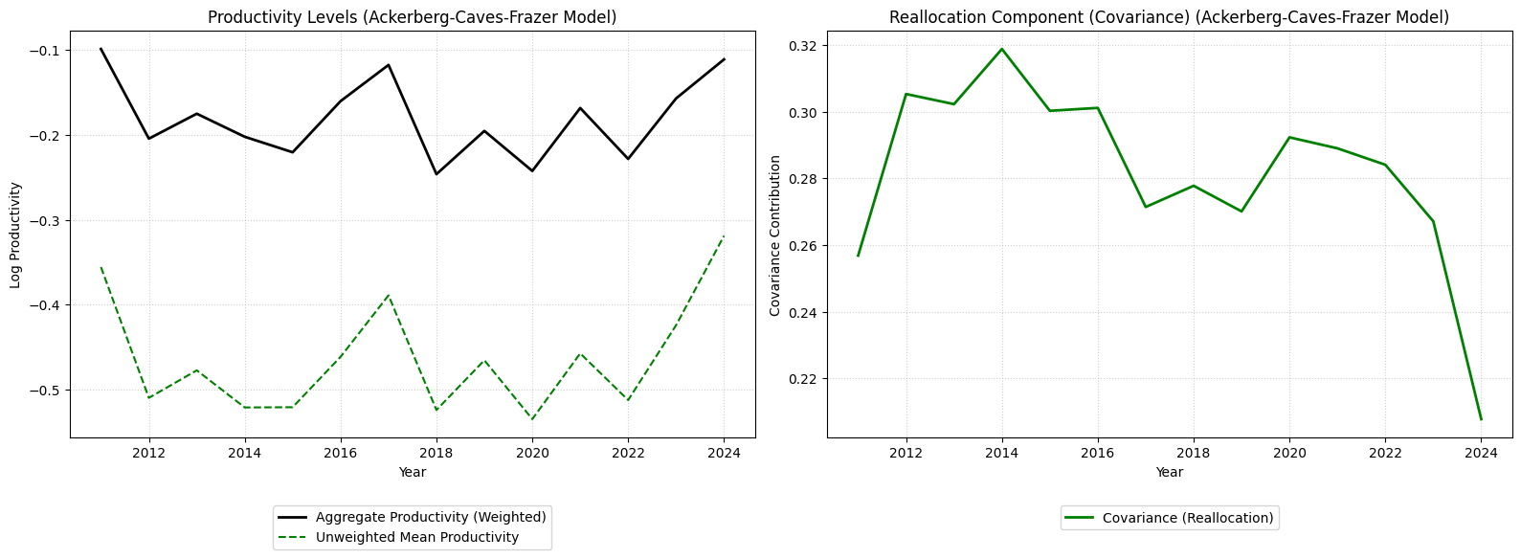
Figure 4.3.1: Industry-Level Aggregate TFP Over Time (ACF Model)
There are a few things to note in the ACF decomposition. First, the overall productivity trajectory broadly mirrors the Olley-Pakes results: aggregate TFP dipped during the 2018–2020 period before recovering through 2024. However, the log productivity levels under the ACF specification are negative throughout the sample, reflecting the fact that the ACF model attributes a larger share of output variation to labor ($β_{l}$ = 0.88) than the OP model ($β_{l}$ = 0.93), leaving less residual variation classified as productivity. This does not indicate that firms are unproductive in an absolute sense, but rather a consequence of the different input elasticities shifting the TFP distribution downward in levels.
Second, the reallocation component under the ACF model tells a different story from the OP decomposition. While the OP results showed the covariance term increasing after 2020, the ACF decomposition shows the reallocation component declining from approximately 0.32 in 2013 to 0.21 in 2024. This divergence likely reflects how the two models assign productivity across firms: because the ACF model attributes more output to labor, firms that are labor-intensive receive lower TFP estimates, reshuffling which firms appear most productive and altering the correlation between productivity and market share. Despite this difference in trend, the covariance term remains positive and substantial under both specifications throughout the sample period, confirming that more productive firms consistently hold larger market shares in the Computer and Electronic Products Manufacturing industry. The sensitivity of the reallocation trend to the choice of estimator underscores the importance of the production function specification for the policy-relevant decomposition of aggregate productivity growth.
Apple remains the single largest contributor under both the OP and ACF specifications, with a cumulative ACF reallocation contribution of 0.134. NVIDIA (NVDA) again shows a clear upward trajectory, with its annual reallocation contribution rising from approximately 0.004 in the early 2010s to 0.009 by 2024, though the magnitude of the post-2020 surge is more muted under ACF than under OP. This dampening reflects the ACF model's higher labor elasticity, which attributes more of NVIDIA's output growth to its expanding workforce rather than to residual productivity. Intel (INTC) remains a declining contributor under ACF, though its reallocation contribution stays positive (0.002 in 2023) rather than turning negative as in the OP decomposition. The ACF model assigns Intel higher TFP because its large capital stock is discounted more heavily under the lower capital elasticity (β_k = 0.35 vs. OP's 0.37). The Spearman rank correlation of firm-level reallocation contributions across the two methods is modest (0.06), driven primarily by instability among small firms whose market shares are too small to materially affect the aggregate decomposition. The finding that design-intensive, IP-driven firms such as Apple and NVIDIA increasingly dominate both productivity and market share while capital-heavy manufacturers decline is robust to the choice of the estimator.
4.3.1. Splitting the Ackerberg-Caves-Frazer Model
To investigate whether the production function has changed over time, I re-estimate the ACF model on two sub-periods: 2011–2016 and 2017–2024. The split at 2017 corresponds to the onset of several structural shifts in the industry, including accelerating demand for AI and high-performance computing, increased domestic semiconductor investment, and early policy discussions around supply chain reshoring that would culminate in the CHIPS and Science Act of 2022.
 | Pre-2017 | 2017 & After
Capital | 0.278 | 0.484
Labor | 0.980 | 0.418
Returns to Scale | 1.258 | 0.902
GMM Objective | 0.00000207 | 0.00021838
Table 4.3.1.1:Ackerberg-Caves-Frazer Model Results Pre- and Post-Split
The results reveal a substantial shift in the industry's production technology. In the pre-2017 period, the industry was highly labor-elastic ($β_{l}$ = 0.98) with a modest capital elasticity ($β_{k}$ = 0.28), indicating that value creation was driven primarily by human capital (e.g., engineers, designers, and software developers). After 2017, capital elasticity nearly doubled to 0.48 while the labor elasticity fell by more than half to 0.42. Returns to scale also shifted from mildly increasing (1.26) to slightly decreasing (0.90), suggesting that the industry moved closer to or past its efficient scale during this period.
This structural break is consistent with several concurrent developments. The rapid expansion of semiconductor fabrication capacity, data center infrastructure, and GPU manufacturing increased the capital intensity of production. At the same time, advances in automation and the continued offshoring of labor-intensive assembly may have reduced the marginal contribution of domestic labor to output. The rising capital elasticity also aligns with the wave of capital investment incentivized by the CHIPS Act and related industrial policy, which directed substantial public and private investment toward domestic manufacturing capacity.
These findings should be interpreted with some caution. The pre-2017 sub-sample is smaller (848 firm-quarter observations compared to 2,737 in the later period), and the GMM objective value for the post-2017 estimation is an order of magnitude larger (0.00022 vs. 0.000002), suggesting weaker identification of the moment conditions in the later period. Several bootstrap iterations in both sub-samples produced outlier estimates, indicating that the smaller samples reduce the precision of the coefficient estimates. Nevertheless, the direction and magnitude of the shift (i.e., from a labor-dominant to a capital-dominant production technology) is robust across starting values and consistent with the broader industry narrative.
5. Discussion
Table 5.1 reveals several patterns across estimation methods. First, the capital coefficient is remarkably stable: $β_{k}$ ranges from 0.35 to 0.65 across methods, with the structural estimators (OP and ACF) converging tightly between 0.35 and 0.37. The OLS estimate of 0.65 is biased upward by simultaneity (i.e., more productive firms invest more in capital) while fixed effects overcorrects downward to 0.23, consistent with the well-documented attenuation bias that arises when capital is a slow-moving state variable and within-firm variation is mostly noise.
Second, the labor coefficient is less precisely identified, ranging from 0.57 (OLS) to 0.92 (OP). The OLS estimate is biased downward relative to the structural methods. However, the downward bias likely reflects the interaction between the generated regressor (QRF-imputed employment) and the OLS specification: measurement error in labor attenuates its coefficient while inflating the capital coefficient.
Third, returns to scale are mildly increasing across all specifications, ranging from 1.22 to 1.29 at the preferred estimates. When more productive firms command higher prices, revenue conflates price and quantity variation, biasing input elasticities upward (De Loecker, 2011). The consistency of this finding across methods suggests that the estimates for returns to scale reflect a genuine feature of the data rather than an artifact of any single estimator.
Taking the ACF global minimum as the preferred specification, a 1% increase in capital raises value added by approximately 0.35%, while a 1% increase in labor raises it by approximately 0.88%. The industry is substantially more responsive to labor than to capital – consistent with the Computer and Electronic Products Manufacturing sector’s reliance on skilled engineering and design labor as a primary driver of value creation.
 | OLS | FE | OP | ACF Global Minimum | ACF Local Minimum
const | 0.43 | 3.44 | - | - | -
Capital | 0.65  (0.00) | 0.23  (0.038) | 0.37 | 0.35  (0.150) | 0.55
Labor | 0.57  (0.02) | 0.85  (0.070) | 0.9156  (0.020) | 0.88  (0.158) | 0.97
RTS | 1.22 | 1.28 | 1.29 | 1.23 | 1.52
R-Squared | 0.96 | 0.55 | 0.934 | - | -
F-Stat | 71,901.38 | 3,806.00 | 9,388 | - | -
Table 5.1: Comparing Regression Results for the Identification Models
6. Limitations
My research faces several limitations that affect the interpretation and generalizability of the findings. First, data heterogeneity and standardization issues pose significant challenges. Firms report capital investments (e.g., property, plant, and equipment, research and development, and intangible assets) differently, making cross-company comparisons difficult. Employment metrics also vary, with some firms reporting only full-time employees while others include contractors, requiring assumptions that may introduce measurement error.
Endogeneity and model specification issues further complicate the study. While fixed effects control for unobserved firm-level heterogeneity, they cannot fully address reverse causality (e.g., whether productivity gains drive workforce reductions or whether layoffs force efficiency improvements). Omitted variable bias is another concern, as unmeasured factors like management quality or industry-specific shocks may influence the results. Multicollinearity among predictors, such as capital expenditures and R&D spending, inflates the variance in coefficient estimates, making it harder to isolate individual effects.
Selection bias is another critical limitation. By focusing only on surviving firms, I may overstate productivity gains, as failed companies with declining efficiency are excluded. The study’s specific time frame (e.g., post-2010) also limits generalizability, as technological and economic conditions vary across different eras. Furthermore, measurement error in key variables, such as employment (which may not account for outsourcing or automation) and capital stock (especially intangible assets like software and patents), introduce noise into the analysis.
Finally, the reliance on observational data means I cannot make definitive causal claims. Unobserved technological shifts, such as rapid AI adoption, may confound the relationship between workforce changes and productivity. Despite these limitations, I mitigate some concerns by using robust standard errors and lagged variables. However, the findings should be interpreted as suggestive rather than conclusive, highlighting the need for future research with richer datasets or quasi-experimental methods to strengthen causal inference.
7. Conclusion

APPENDIX A: Estimating Quarterly Employment Data
Because quarterly financial statement data from Compustat Capital-IQ does not include data for the number of employees for any company, I adapted code created by McBride, Ellis (2024) to estimate quarterly data for the number of employees based on annual data using a QRF. I chose to use a quantile regression forest as the financial statement data is highly dimensional and skewed, leading to poor estimates of employment for very large companies when using less advanced regression techniques, such as multiple linear regression.
By training a QRF model to estimate quarterly employment, the model will be more accurate for firms across the size spectrum, including those at the upper and lower tails of the distribution. Unlike traditional linear regressions, which only model the conditional mean and assume constant variance, QRFs estimate the full conditional distribution of employment. This allows for more robust predictions, particularly for firms with atypical financial structures or outlier characteristics. Additionally, QRFs naturally handle non-linear relationships and multicollinearity without the need for manual feature engineering or transformation, making them well-suited for high-dimensional and skewed financial datasets.
To further improve interval validity, I apply the conformal quantile regression (CQR) method proposed by Romano et al. (2019), which uses a separate calibration set to adjust the estimated quantile intervals to achieve finite-sample coverage guarantees. Specifically, I compute conformity scores based on the maximum deviation between the observed values and the predicted interval bounds and inflate the original intervals accordingly. This adjustment ensures that the final prediction intervals attain the desired marginal coverage (e.g., 90%) regardless of the underlying distribution or model miscalibration.
To capture heterogeneity in prediction accuracy across the employment distribution, I train separate QRF models for each decile of annual employment, allowing for more precise estimation in the tails. The resulting models outperform traditional linear regressions in both accuracy and reliability, particularly for large firms where linear methods tend to underestimate employment due to non-linearity and multicollinearity among predictors.
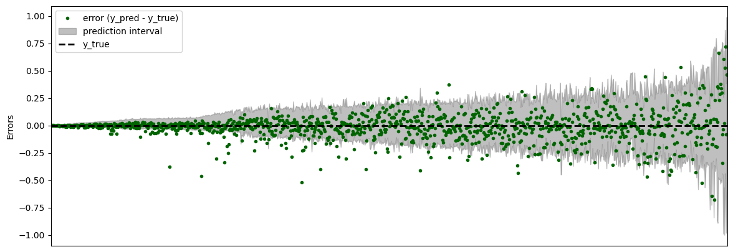
Figure A2: Error Plot Sorted by Prediction Interval Width
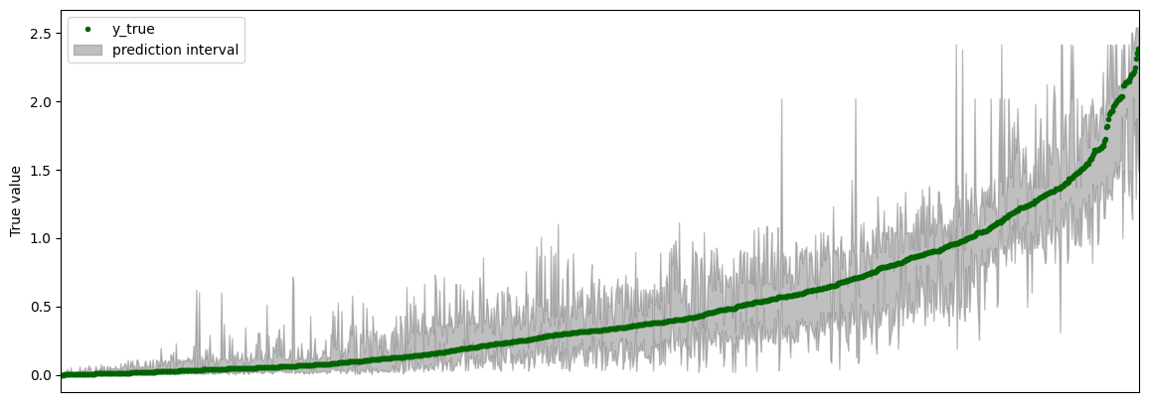
Figure A3: Prediction Intervals Across the Employment Distribution
Figure A2 displays the prediction errors (i.e., predicted minus true employment) alongside conformal prediction intervals sorted by interval width. The error points remain centered around zero, indicating that the model is unbiased across most of the distribution. However, the width of the prediction intervals increases substantially in the right tail, suggesting greater uncertainty in employment predictions for larger firms. This aligns with the observed heteroskedasticity in the earlier residual plots and highlights the model’s adaptive behavior of generating wider intervals where prediction risk is higher to maintain valid coverage.
Figure A3 shows the true number of employees sorted in ascending order, overlaid with their corresponding prediction intervals. The conformal intervals remain tight and consistent throughout the lower and middle ranges of the distribution but expand considerably in the upper tail. This expansion illustrates how the model responds to increasing variance and uncertainty associated with large firms. The widening intervals provide meaningful uncertainty quantification while maintaining full coverage, albeit at the cost of wider intervals in the extremes.
The conformal prediction intervals produced by the Quantile Regression Forests achieve full empirical coverage, with 100% of ground truth employment values falling within their respective intervals. However, the resulting Mean Winkler Interval Score (MWIS) of 54.624 suggests that the intervals are relatively wide. This reflects a tradeoff between validity (coverage) and efficiency (interval tightness), which is inherent in conformal methods. While the intervals may be conservative, they ensure robustness across the entire conditional distribution, particularly in the presence of heteroskedasticity and distributional shift.
To assess the efficiency of the conformal prediction intervals produced by the QRF model, I examined the distribution of interval widths. The median interval width was 0.74, indicating that for most firms, the prediction intervals were relatively tight. However, the 90th percentile interval width increased to 11.03, the 95th percentile to 98.02, and the 99th percentile to 238.20. This widespread reflects the model’s adaptive response to varying levels of uncertainty across firms.
To evaluate whether quarterly data was drawn from the same distribution as the annual training data, I trained a binary Random Forest Classifier to distinguish between the two. The classifier achieved a cross-validated accuracy of 99.99%, indicating a strong distributional shift between the datasets. This finding suggests that the financial feature patterns in the quarterly data differ substantially from those in the annual data, which may limit the generalizability of the QRF model and introduce bias in predicted employment estimates.
Although a classifier accuracy of 99.99% is unusually high, this result does not indicate a problematic distributional shift in the context of the study. The classifier was designed to distinguish between quarterly observations based on the firm-year to which they belonged, using financial statement variables as predictors. However, since quarterly employment figures were constructed by interpolating annual employment data, often using financial variables that are smooth and seasonally stable, the classifier was effectively distinguishing between pre-engineered groupings with highly predictable structure. In other words, the classification task was not learning patterns from independently varying labels but from a target constructed directly from financial inputs. Therefore, the near-perfect accuracy reflects the strong internal consistency of the data rather than overfitting or leakage. Since the primary goal was to estimate conditional distributions of employment within this fixed structure, not to generalize to new or temporally distant contexts, the high classifier performance does not compromise the validity of the quantile regression forest estimates.

APPENDIX B: Cobb-Douglass Production Function
Throughout the paper, I used a Cobb-Douglass production function in the regression analyses. In this Appendix, I assess whether the assumptions of the Cobb-Douglass production function hold given the results from the ordinary least squares regression in Table 3.2.
The Cobb-Douglass production function makes the following assumptions:
- Constant Returns to Scale: $Y=zF\left(αK, αL\right)$
- Positive Marginal Product of Capital and Labor.
- Diminishing Returns to Capital and Labor.
The positive coefficients for capital (0.81 and 0.50) and labor (5.46 and 27.95) in both models shows that the marginal product of capital and the marginal product of labor is positive. Summary statistics for the marginal products of capital and labor support the theoretical assumption of diminishing marginal returns. The mean marginal product of capital is 0.46, with a maximum of 2.70 and a minimum of 0.06. Similarly, the mean marginal product of labor is 0.61, with a maximum of 3.30 and a minimum of 0.17. The range between the mean and maximum values, combined with the declining trend observed in firm-level MPK and MPN, suggests that as firms accumulate more capital or labor, the unit increase in output from an additional unit of capital or labor decreases. Finally, based on a scatterplot of the relation between capital and output and labor and output, capital and labor appear to exhibit constant returns to scale.
Variable | Mean  (in millions) | St. Dev.  (in millions) | Min  (in millions) | Max  (in millions)
Marginal Product of Capital | 0.41 | 0.28 | 0.0002 | 21.02
Marginal Product of Labor | 3.24 | 13.52 | 0.68 | 630.49
Table A1: Summary Statistics for the Marginal Product of Capital and Labor
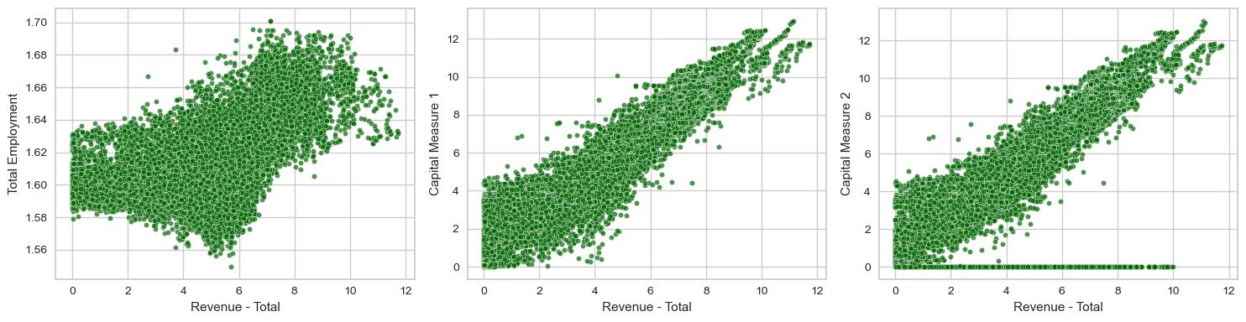
Table A2: Returns to Scale of Capital and Labor

The median for log labor is negative because the dataset is scaled to millions and the median number of employees for firms in the dataset is less than 1,000,000. For example, a firm with 350,000 employees has a value for log labor of -1.05, because log(0.350) = -1.05.
For reference, between-unit variation is calculated as $\sum_{t=1}^{G}{{\left({\overline{y}}_{i}-\overline{y}\right)}^{2}}*n_{i}$.
I exclude 2025 from Figure 4.2.1 because it is an incomplete year. Firms with later fiscal year-ends had not yet released financial statement data, resulting in a non-representative subset of firms that would bias both the mean productivity and the reallocation component.
I exclude 2025 from Figure 4.1.1 because it is an incomplete year. Firms with later fiscal year-ends had not yet released financial statement data, resulting in a non-representative subset of firms that would bias both the mean productivity and the reallocation component.
Returns to Scale
OLS uses log revenue as the dependent variable while OP and ACF use log value added, and ACF standard errors are from a cluster bootstrap with 50 replications.

